Estimate the Crop Yield using Data Analytics

TEAM ID: PNT2022TMID38310

Team Leader : Anish Banu A

Team Members : Kaviya S

Tamil Selvan R

Sakthivel V

**Abstract**

Data analytics is the process of examining data sets in order to find trends and draw conclusions about the information they contain. By using Agriculture Data Analytics in Crop Yield, we will be able to analyze some important visualizations, create a dashboard, and gain most of the insights into Crop production in India. In Cognos Analytics, we can understand our organization's data and make effective decisions based on reporting, modeling, analysis, exploration, dashboards, stories, and event management. Dashboards help us keep track of events or activities at a glance by providing key insights and analysis about our data. A dashboard is used in this project to visualize, analyze, and gain insight.

**Introduction**

Agriculture is an important sector of Indian economy as it contributes about 17% to the total GDP and provides employment to over 60% of the population. Several factors contribute to the low crop yields experienced by Indian farmers. The yield of agricultural crops is largely determined by weather conditions. Rainfall conditions also influences the rice cultivation. Therefore, farmers need a timely forecast of future crop productivity and an analysis is needed so that they can maximize crop production in their crops. Yield prediction is an important problem in agriculture because it directly affects the crop productivity. Every farmer is involved in knowing, how lots yield he is about expect. In the past, yield prediction wasonce carried out by using thinking about farmer's preceding trip on a unique crop. The data will be very useful when it is converted into an information by transforming it. IBM Cognos Business Intelligence is a web-based integrated business intelligence suite by IBM. It provides a toolset for reporting, analytics, score carding, and monitoring of events and metrics. The software consists of several components designed to meet the different information requirements in a company. Cognos event studio allows you to assign a specific event that sends a notification to the stakeholder in your organization. Cognos Metric Studio allows you to monitor and analyze business metrics of your organization by building a scorecard environment.

**Literature Survey**

P. Vindya “Agricultural Analysis for Next Generation High Tech Farming in Data Mining” , Anna University, Trichy, Tamilnadu, India, 5 May 2015[2]. Recent developments in Information Technology for agriculture field have become an interesting research area to predict the crop yield [1].

In today’s world, the amount of information stored has been enormously increasing day by day which is generally in the unstructured form and cannot be used for any processing to extract useful information using mining technique [2]. This paper presents a brief analysis of data mining methods and agriculture techniques, farm types, soil types, prediction using Multiple Linear Regression (MLR) technique for the selected region. This work mainly focuses on analyzing the agricultural analysis of organic farming and inorganic farming, time cultivation of the plant, profit and loss of the data and analyzes the real estate business land in a specific area and comparison of irrigated and unirrigated land. It concentrates organic, inorganic and real estate data sets from which the prediction in agriculture will be achieved. The purpose is to estimate difference in efficiency and prediction between organic and inorganic farming. This work aims at finding suitable data models that achieve a high accuracy and a high generality in terms of yield prediction capabilities.

Crop Yield Prediction Using Machine Learning A  research group  investigated the  utilization of various  information mining  methods which  will foresee rice crop yield for the data collected from the state of Maharashtra, India. A total of 27 regions of Maharashtra were selected for the assessment and the data was collected related to the principle rice crop yield influencing  parameters  such as  different atmospheric  conditions and  various harvest parameters  i.e Precipitation rate,  minimum, average,  maximum and  most extreme temperature,  reference trim  cultivable area, evapotranspiration, and yield for the season between June to November referred as Kharif, for the years 1998 to 2002 from the open source, Indian Administration records. WEKA a Java based dialect programming for less challenging assistance with  information data sets, assigning design  outcomes tool  was applied for dataset  processing and  the overall  methodology of  the study  includes,  (1) pre-processing  of dataset  (2) Building the prediction model utilizing WEKA and (3) Analyzing the outcomes. Cross validation  study is carried out to scrutinize how a predictable information mining method will execute on an ambiguous dataset. Study  applied 10-fold  higher cross  validation  study  design  to assess  the data  subsets  for  screening and testing. Identified  and collected information  was randomly distributed  into 10 sections where  in one data section was used for testing while all other data sections were utilized for the preparation information. Study reported that the method applied was supportive in the precise estimation of rice crop yield for the state of Maharashtra, India. The precise quantification of the rice productivity in various climatic conditions can help farmer to understand the optimum condition for the higher rice crop yield [8].

Simulation  models  based  on  field  experiment  are  valuable  technologies  for  studying  and understanding crop yield gaps, but one of the critical challenge remain with these methods is scaling up of these approach  to assess the  data collated between different  time intervals  from the  broader geographical regions.  Satellite  retrieved  data  have  frequently  been  revealed  to  present  data sets  that,  by  itself  or in grouping with other information and model designs, can precisely determine the yields of crop in agricultural lands. The yield maps developed shall provide an unique opportunity to overcome both spatial and temporal based scaling up  challenges and  thus improve  the ideology  of crop  yield gaps  prediction. A  review was conducted to discuss the applications of remote sensing technology to determine the impact and  causes of yield gaps. Even though the example discussed by the research group demonstrates the usefulness of remote sensing in the prediction of yield gaps, but also many areas of possible application with respect to the crop yield assessment,  prediction  and improvement  remain unexplored.  Study proposed  two less  complicated, easily  assessable  methods  to  determine  and  quantify the  yield  gaps  between  various  agricultural  fields.  First method works closely with the constructive maps representing the average crop yields, it can be used directly to accesses specific crop yield influencing factors for further studies whereas the second method use the remote sensing technology to retrieve the data for providing the useful information regarding the crop yield prediction and estimation [14].

M. Chandraprabha and R. K. Dhanaraj, "Soil Based Prediction for Crop Yield using Predictive Analytics," 2021 3rd International Conference on Advances in Computing, Communication Control and Networking.  Predictive analysis is a technique of machine learning that predicts the future outcomes and analysis is based on the historical or past data. In agriculture, predictive analytics helps to predict or identify the soil nutrients level required for the crops like Paddy, Raagi, Cumbu etc.,. In this paper, the soil based dataset is collected from TNAU website and it has 32 districts of Tamilnadu. The algorithms such as Naïve bayes, Bayes Net, and IbK have been deployed to predict the crop variety suitable for the soil based on the total production and area sown district wise. Also, its accuracy levels are compared. The accuracy is determined using true positive value, false positive value, precision, recall, f-measure and MCC.

B. Vandana and S. S. Kumar, "A Novel Approach using Big Data Analytics to Improve the Crop Yield in Precision Agriculture," 2018 3rd IEEE International Conference on Recent Trends in Electronics, Information & Communication Technology. Agriculture is the main work field in India. Farming industry adopts less innovative technology compared to other industries. Information and Communication Technologies provides simple and cost effective techniques for farmers to enable precision agriculture. The work propose a state of the art model in agriculture field which will guide the rural farmers to use Information and Communication technologies (ICT) in agriculture fields. Big data analytics is used to improve the crop yield. It can be customized for precision agriculture to improve the quality of crops which improves the overall production rate.

S. Sharma, G. Rathee and H. Saini, "Big Data Analytics for Crop Prediction Mode Using Optimization Technique," 2018 Fifth International Conference on Parallel, Distributed and Grid Computing. Agriculture is considered as the backbone of our country's economy. Big data analysis is used to discover novel solutions, which act as means for analyzing bulky data set, so that it plays a significant role for decision making in specific field such as agriculture. In this work, soil and environment features i.e. average temperature, average humidity, total rainfall and production yield are used in predicting two classes namely: good yield and bad yield. For this purpose, a hybrid classifier model is used in optimizing the feature and the proposed approach is divided into three phase's viz pre-processing, feature selection and SVM_GWO i.e grey wolf optimizer along with Support Vector machine (SVM) classification is used to improve the accuracy, precision, recall and F-measure. The result shows that SVM_GWO approach better as compared to typical SVMs classification algorithm.

S. Bao et al., "Crop yield variation trend and distribution pattern in recent ten years," 2017 IEEE International Geoscience and Remote Sensing Symposium. In recent ten years, a perception exists that the agricultural management and crop cultivars have been improved obviously. But the crop yield variation trend due to above reason remain unknown yet. To evaluate the main food crop (maize, soybean and rice) yield trend from 2007 to 2016, the MODIS product (MCD12Q2) was used to extract the mature date of different crops. A two-band variant of the enhanced vegetation index at mature date was applied to establish empirical yield estimation model, coupling with statistical crop yield data. The validation show the estimated yield had accuracy of 90.9%, 91.7% and 83.3%, respectively. The average maize and soybean yield in study area presented increasing trend, but rice yield presented declining. However, maize yield in 22 cities and soybean yield in 19 cities show decreasing trend actually. Through statistical analysis, the crop yield distribution pattern was proved to be almost fixed. Most cities occupies approximate position on the ranking of relevant crop yield. It was demonstrated that some cities, for example Chifeng city, was suitable to develop specific agriculture economy. This paper can be used to give suggestion for agriculture planning and management.

**Ideation and Proposed Solution**

**A. IBM Cognos Analytics**

IBM Cognos Analytics is a set of business intelligence tools available on cloud or on- premise. The primary focus is in the area of Descriptive Analytics, to help users see the information in your data through dashboards, professional reporting and self-service data exploration. In this work, we used the IBM cognos data analytics for analyzing the crop yield data.

Following are important features of IBM Cognos:

1. *Get Connected -* Connect your data effortlessly Import data from CSV files and spreadsheets. Connect to cloud or on-premises data sources, including SQL databases, Google BigQuery, Amazon, Redshift, and more.
2. *Prepare your data –* Prepare and connect data automatically Save time cleaning your data with AI-assisted data preparation. Clean and prep data from multiple sources, add calculated fields, join data, and create new tables.
3. *Build visualizations -* Create dynamic dashboards easily Quickly create compelling, interactive dashboards. Drag and drop data to create auto- generated visualizations, drill down for more detail, and share using email or Slack.
4. *Identify Patterns –* Uncover hidden patterns Ask the AI assistant a question in plain language, and see the answer in visualization. Use time series modelling to predict seasonal trends.
5. *Generate Personalized Reports –* Create and deliver personalized reports Keep your stakeholders up-to-date, automatically. Create and share dynamic personalized, multi-page reports in the formats your stakeholders want.
6. *Gain Insights -* Make confident data decisions Get deeper insights without a data science background. Validate what you know, identify what you don't with statistically accurate time-series forecasting and pinpoint patterns to consider.
7. *Stay Connected –* Go Mobile Stay connected on the go with the new mobile app. Access data and get alerts right from your phone.

Important Components of Cognos Software:

a. Cognos Connection:Cognos connection is a web portal that allows users to access Cognos 10 and studios. Based on your assigned role, you can use this component to retrieve, view, publish, manage, and organize companies’ reports, scoreboards, and agents. The Administrator also using Cognos Connection to establish roles and user permissions and manage the Cognos Connection content.

b. Cognos Business Insight:Cognos Business Insight allows users to create their dashboard using any object. All content which the user is permitted to view will be presented as an object. This can be used in your workspace to create a fully personalized dashboard.

c. Cognos Query Studio:Cognos Query Studio helps business users to get fast answers to business related queries. It helps organizations to better understand the product, customer, and organizational needs. It also helps them to react quickly and stay ahead of the competition.

d. Cognos Analysis Studio: Cognos Analysis Studio helps businesses to find and focus on things which are important to the business. It also helps to understand the latest trends, compare data, and assess business performance for multidimensional analysis.

e. Cognos Business Insight Advanced: Cognos business insight Advanced is a new module included in Cognos 10. It combines Cognos query studio and Cognos Analysis Studio. It offers robust authoring environment for business peoples.

f. Cognos Report Studio:Using the Cognos reporting tool, you can create pixel-perfect reports for your organization. It allows you to create charts, maps, lists, or any other available report type using relational or multidimensional data sources.

g. Cognos Event Studio: This tool allows you to assign a specific event that sends a notification to the stakeholder in your organization. You can create agents which enables you to your events and thresholds. Therefore, the event occurs or threshold is reached the agent sends the notification.

h. Cognos Metric Studio:Cognos Metric Studio allows you to monitor and analyse business metrics of your organization by building a scorecard environment. It also helps you to establish criteria and then monitor your organization to see how it is responding as the changes made in the criteria.

**B. System Architecture**

IBM Cognos Analytics provides dashboards and stories to communicate your insights and analysis. You can assemble a view that contains visualizations such as a graph, chart, plot, table, map, or any other visual representation of data. Explore powerful visualizations of your data in IBM Cognos Analytics and discover patterns and relationships that impact your business. A dashboard helps you to monitor events or activities at a glance by providing key insights and analysis about your data on one or more pages or screens.

The following are the modules in our work:

1. Uploading data (dataset).
2. Cleaning data (prepare data).
3. Analyzing and interpreting (exploration).
4. Visualizing data (dashboard creation).

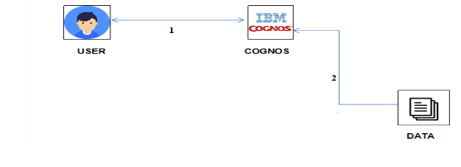

**Empathy Map Canvas**

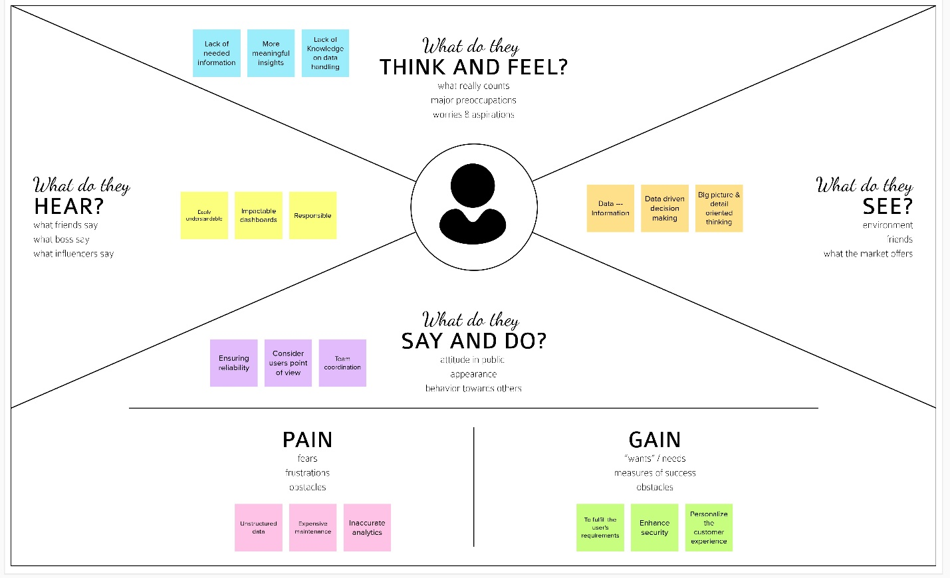

**Ideation & Brainstorming**

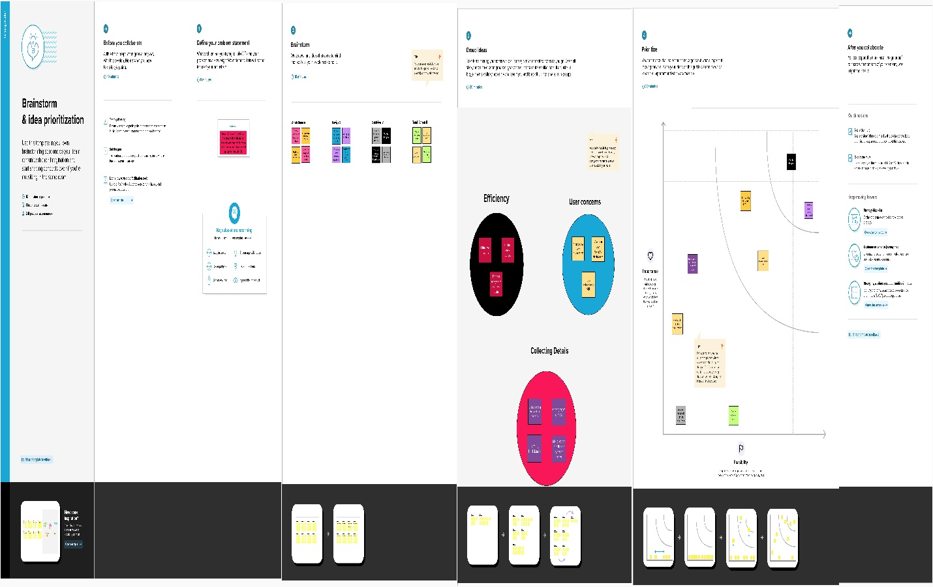

**Proposed Solution**

|  |  |  |
| --- | --- | --- |
| **S.NO.** | **PARAMETER** | **DESCRIPTION** |
| 1. | Problem Statement  (Problem to be solved) | To estimate the crop yield with atmost accuracy so that the Farmers, Government and Traders will get gain through it and it will lead them to make data - driven discision - making. |
| 2. | Idea / Solution description | To create user understandable dashboards so that the farmers get valuable insights about various types of crop production. |
| 3. | Novelty / Uniqueness | Using a well-researched dataset includes types of crops, regions, seasons, climatic conditions, temperature suggestions can be made on what type of crop is suitable for a particular land at a specific season to get maximum harvest. |
| 4. | Social Impact / Customer  Satisfaction | Maximum accuracy in the output will give maximum crop yield. As more revenue will be made, the customer will be satisfied. |
| 5. | Business Model  (Revenue Model) | A satisfied customer can share his experience to somebody which results in large number of customer base. More revenue can be made by providing subscription services. |
| 6. | Scalability of the Solution | There is no problem with the dataset storage, time efficient, accurate, clear insights and an efficient way to forecast the upcoming results. |

**Problem Solution fit**

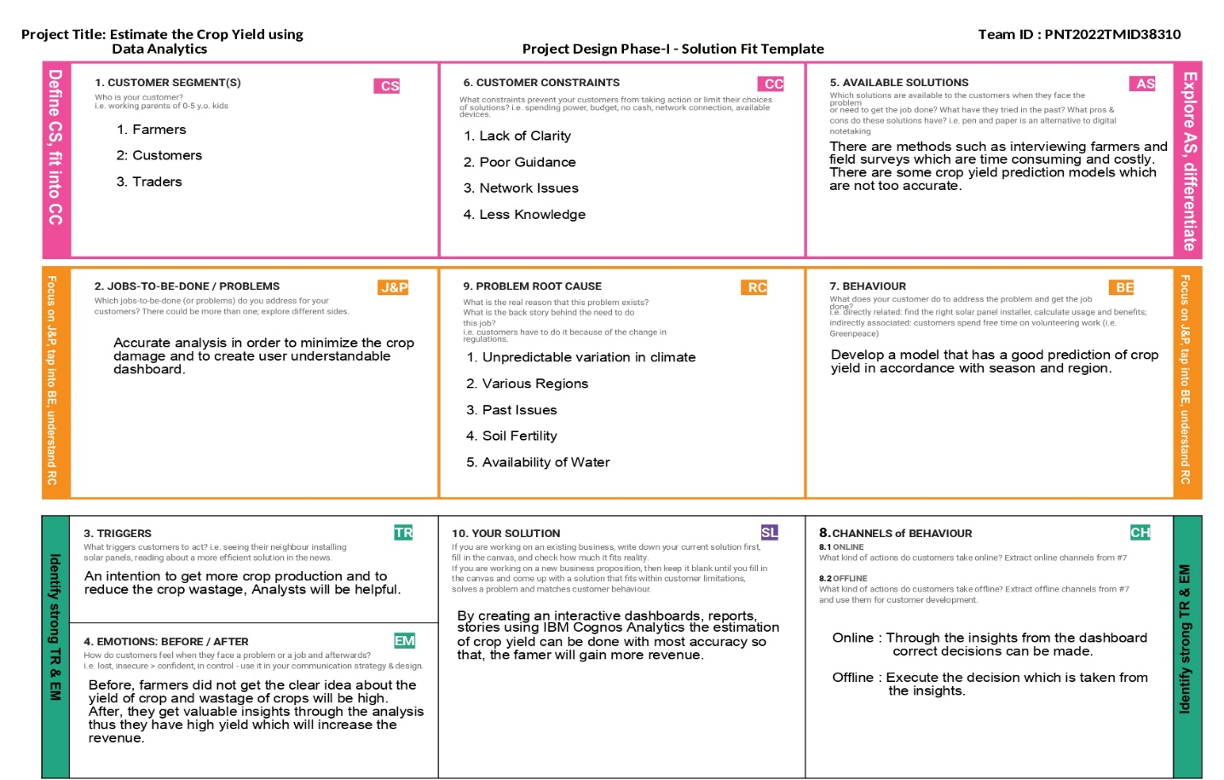

**Requirement Analysis**

**Functional Requirement:**

Following are the functional requirements of the proposed solution

|  |  |  |
| --- | --- | --- |
| **FR No.** | **Functional Requirement (Epic)** | **Sub Requirement (Story / Sub-Task)** |
| FR-1 | User Registration | Utilizing a form for Registration and Signing up with Gmail registering via WhatsApp, Utilizing Agri - Consultancy to register. |
| FR-2 | User Confirmation | Email confirmation required Reassurance via OTP verification via Letter. |
| FR-3 | User Profile | 1. User Information 2. Farm Information |
| FR-4 | Required Data | The user’s (farmer’s) data to analyse the previous crop yield |
| FR-5 | Analysis | Clean up, prepare and analyze the previous data from multiple users (farmer) |
| FR-6 | Estimation | Developing the ideal data module and visuals in IBM Cognos to improve crop yield estimation. |

**Non-Functional requirements:**

Following are the non-functional requirements of the proposed solution

|  |  |  |
| --- | --- | --- |
| FR No. | Non-Functional Requirement | Description |
| NFR-1 | Usability | Data reports are produced based on the historical data itself. These recommendations will advise or consult on crop sowing. |
| NFR-2 | Security | The user information is protected with IBM Cognos (Data Visuals) |
| NFR-3 | Reliability | Reliability can be achieved with the saved dataset in the Cognos platform. |
| NFR-4 | Performance | Better performance among all users is made possible through interaction, and the visual advice is impressive. |
| NFR-5 | Availability | The dashboard is easily accessible and can be accessed on any smartphones, laptops, systems, etc. |
| NFR-6 | Scalability | The proposed solution's flexibility in implementation makes it very simple to boost crop yield estimation in various farms. |

**Project Design**

**Data Flow Diagrams:**

A Data Flow Diagram (DFD) is a traditional visual representation of the information flows within a system. A neat and clear DFD can depict the right amount of the system requirement graphically. It shows how data enters and leaves the system, what changes the information, and where data is stored.

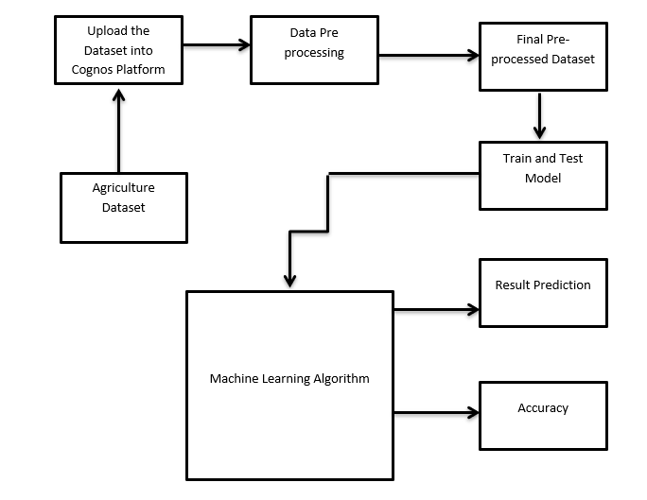

**User Stories:**

Use the below template to list all the user stories for the product

|  |  |  |  |  |  |  |
| --- | --- | --- | --- | --- | --- | --- |
| User Type | Functional Requirement (Epic) | User Story Number | User Story / Task | Acceptance criteria | Priority | Release |
| Customer (Mobile user) | Registration | USN-1 | As a user, I can register for the application by entering my email, password, and confirming my password. | I can access my account /dashboard. | High | Sprint-1 |
|  |  | USN-2 | As a user, I will receive confirmation email once I have registered for the application. | I can receive confirmation email & click confirm. | High | Sprint-1 |
|  |  | USN-3 | As a user, I can register for the application through Facebook | I can register & access the dashboard with Facebook Login. | Low | Sprint-2 |
|  |  | USN-4 | As a user, I can register for the application through Gmail. |  | Medium | Sprint-1 |
|  | Login | USN-5 | As a user, I can log into the application by entering email & password. |  | High | Sprint-1 |
|  | Dashboard | USN-6 | Can use the methods provided in the  Dashboard. |  | Medium | Sprint-2 |
| Customer (Web user) | Activity | USN-7 | I can register for the application through any  web browser. | I can get an notification from the browser. | Low | Sprint-1 |
| Customer Care Executive | Access resources | USN-8 | I can use my credentials For accessing my  Resources. | Other than me, there is less chance to access my  Resources. | High | Sprint-1 |
| Administrator | Satellite visioning | USN-9 | As, a user I can vision the geographic area. |  | Medium | Sprint 2 |
| Customer tools | Tools | USN-10 | I can perform analysis by tools (cognos and  with ML) | I have an ease of  Accessing tools. | High | Sprint 1 |

**Technical Architecture:**

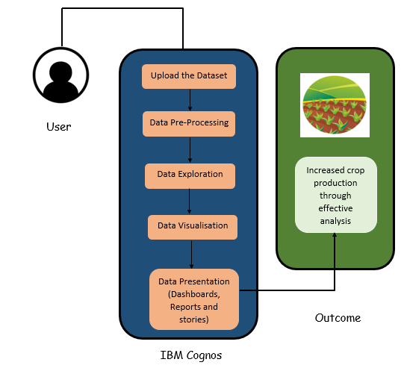

**Project Flow**

* Users create multiple analysis graphs/charts.
* Using the analyzed chart creation of the Dashboard is done.
* Saving and Visualizing the final dashboard in the IBM Cognos Analytics.

**To accomplish this, we have to complete all the activities and tasks listed below:**

* Login to Cognos Analytics.
* Working with the Dataset
* Understand the Dataset.
* Loading the Dataset.
* Data visualization charts
* Seasons with average productions.
* With years usage of Area and Production.
* Top 10 States with most area.
* State with crop production.
* States with the crop production along with season (Text Table).
* Dashboard Creation.
* Export the Analytics.

**Project Planning and Scheduling**

**Sprint Planning and Estimation:**

Product Backlog, Sprint Schedule, and Estimation

|  |  |  |  |  |  |  |
| --- | --- | --- | --- | --- | --- | --- |
| **Sprint** | **Functional Requirement (Epic)** | **User Story Number** | **User Story / Task** | **Story Points** | **Priority** | **Team Members** |
| Sprint-1 | Registration | USN-1 | As a user, I can register for the application by entering my email, password, and confirming my password. | 2 | High | Anish Banu A Kaviya S  Tamil Selvan R Sakthivel V |
| Sprint-1 | Registration | USN-2 | As a user, I will receive confirmation email once I have registered for the  application | 1 | High | Anish Banu A Kaviya S |
| Sprint-2 | Registration | USN-3 | As a user, I can register for the application through Facebook | 2 | Low | Tamil Selvan R Sakthivel V |
| Sprint-1 | Registration | USN-4 | As a user, I can register for the application through Gmail | 2 | Medium | Kaviya S Sakthivel V |
| Sprint-1 | Login | USN-5 | As a user, I can log into the application by entering email  & password | 1 | High | Anish Banu A Tamil Selvan R |
| Sprint-1 | Dashboard | USN-6 | As a user, I can use the methods provided in the dashboard | 2 | Medium | Kaviya S Sakthivel V |
| Sprint-2 | Prediction | USN-7 | As a user, with the results obtained, I can  determine whether profit or loss is made | 2 | High | Anish Banu A Tamil Selvan R Sakthivel V |
| Sprint-3 | Visualisation | USN-8 | Having a view with geographic data | 2 | High | Tamil Selvan R Kaviya S |
| Sprint-3 | Customer Care | USN-9 | As a Customer Care Executive, I can answer users’ queries | 2 | Low | Sakthivel V Anish Banu A |
| Sprint-4 | Tools | USN-10 | Analysis is performed by tools like cognos analytics | 1 | High | Anish Banu A |
| Sprint-4 | Administrator | USN-11 | As an admin, I can make changes to the interface according the needs | 3 | High | Anish Banu A Kaviya S  Tamil Selvan R Sakthivel V |

**Results**

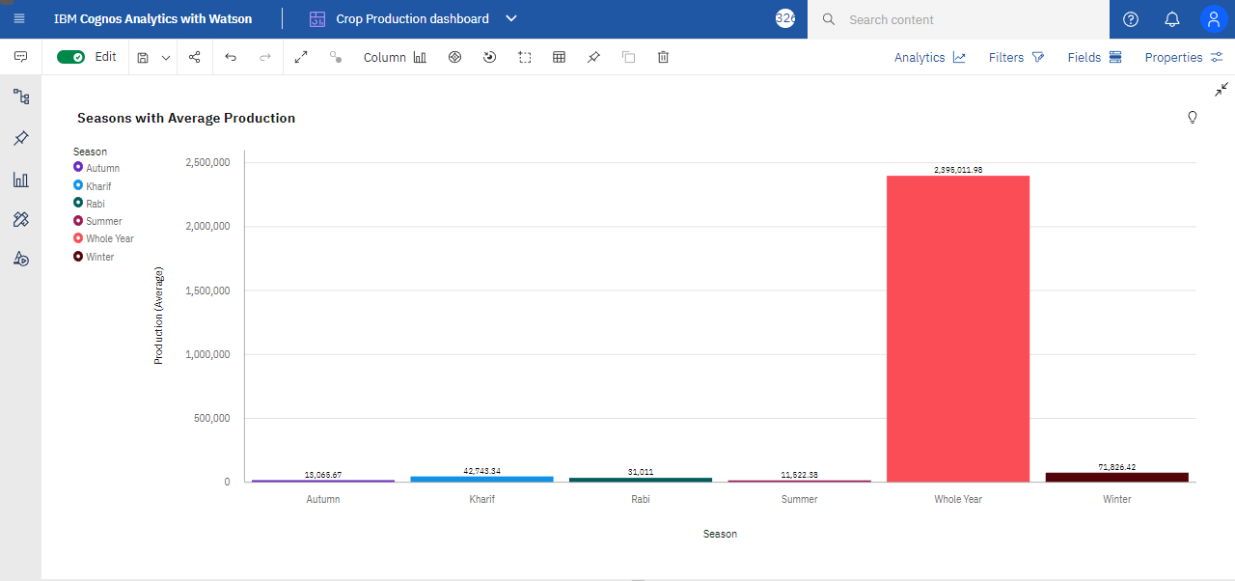

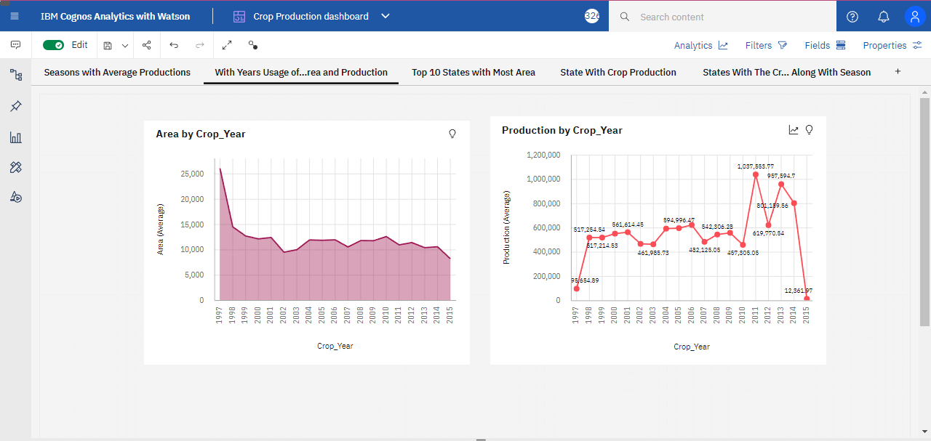

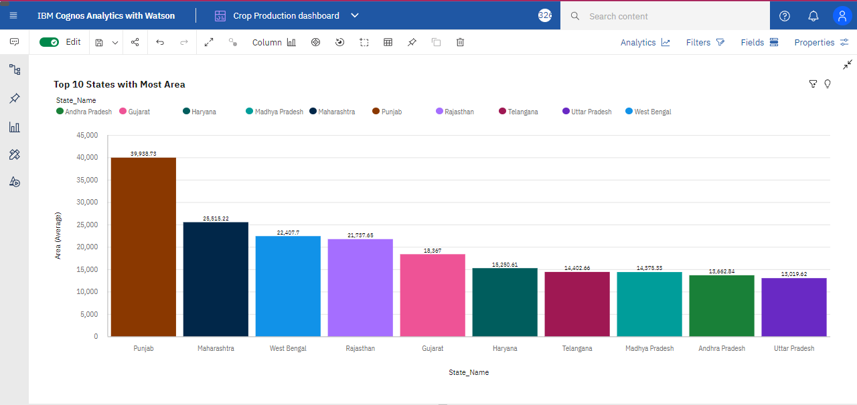

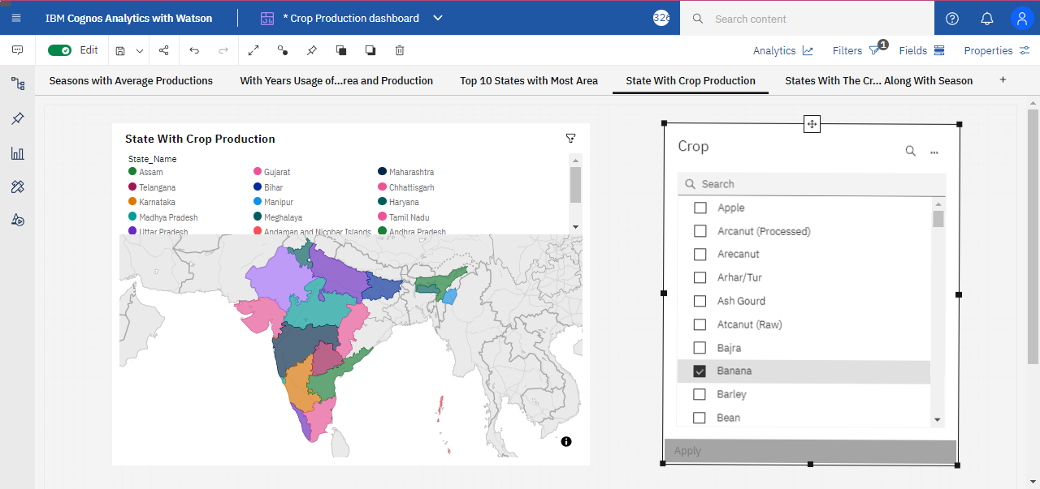

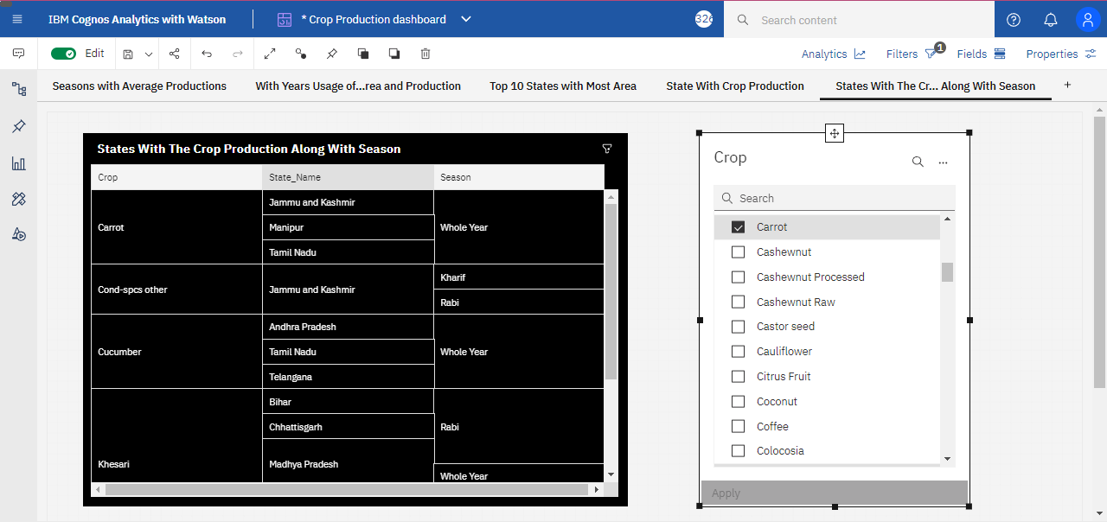

**Conclusion**

As a result of penetration of technology into agriculture field, there is a marginal improvement in the productivity. The innovations have led to new concepts like digital agriculture, smart farming, precision agriculture etc. In the literature, it has been observed that analysis has been done on agriculture productivity, hidden patterns discovery using data set related to seasons and crop yields data. We have noticed and made analysis about different crops cultivated, area and productions in different states and districts using IBM Cognos.

**Appendix**

**Project Demo Link:** https://youtu.be/cBKL88Wgx1k